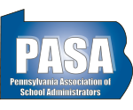
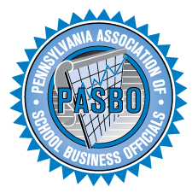

June 7, 2019
House State Government Committee
Pennsylvania House of Representatives
Re: House Bill 1069
Dear Representative,
On behalf of the school board members, school administrators, and business officials who oversee the commonwealth’s public school districts, we are writing to express our concern with House Bill 1069 (Rep. Bernstine - Lawrence) to be considered by the House State Government Committee on June 12, 2019. House Bill 1069 would mandate school boards to make meeting agendas, including a listing of each matter of business that will be the subject of official action and/or deliberation, available to the public prior to all public meetings. This concerns us as agendas evolve continuously up to the time of the meeting in many cases. Some matters a board must approve are added to agendas at the last minute, not because the matter arises at the last minute, but because some necessary information or PDE approval necessary for the board to take action comes through at the last minute. In these situations, delaying action to the next month would be disadvantageous, costly to taxpayers or involve other negative consequences to the district.
A common example is a construction project change order – architect’s review and recommendation could come through the morning of the meeting, and if not approved that night, could hold up the whole project. Additionally, this bill could impact teaching positions that could be left unfilled in September because some candidates applying in multiple districts did not accept an offer until the day of the August board meeting, or they lacked some item of paperwork they needed from PDE.
This legislation could have many unforeseen outcomes:
- It could force boards to meet more often;
- It could delay important business, interrupt critical path coordination, and open up all manner of actions to legal challenge and disputes about what qualifies for exceptions, or whether something was adequately described in a posted agenda.
- It could create agendas that could be a mile long, including all kinds of “just in case” items like the examples above that may or may not actually be acted on at that meeting.
For these reasons, PSBA, PASA, and PASBO oppose House Bill 1069. We appreciate your time and attention to these matters.

