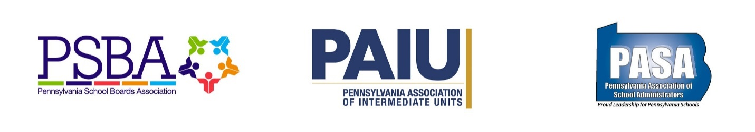

Priority Issue: 2019-20 State Budget

The Pennsylvania School Boards Association (PSBA), PA Association of School Administrators (PASA), and the PA Association of Intermediate Units (PAIU) urge the General Assembly to support these critical investments in the 2019-20 state budget:

Investments for basic education funding
Recommendation:
- Support a minimum $200 million increase for the BEF line item.

School officials are very appreciative of the investments made in basic education funding (BEF) made during the last four years. However, even those significant investments have failed to surpass the increase in what school districts have been required to contribute in their share of mandatory payments for pension, charter school tuition, special education and other costs. In areas where school districts have control over spending, they have been doing all they can to control costs. School districts have reduced staffing/salaries and have taken other measures to save money. In fact, the data shows school districts acting responsibly to reduce expenses where possible and keep controllable areas of growing expense well below the rate of inflation.

Pennsylvania must support a significant and continued financial investment for school districts that is distributed using the funding formula established under Act 35 of 2016 that provides districts with the greatest flexibility to use their resources. Accelerating the work of the new BEF formula is necessary to ensure that school districts see an increase in BEF funding which will provide much needed resources.

Investments for special education funding
Recommendation:
- Support a minimum $50 million increase for special education.

The education of children with disabilities is one of the most important responsibilities of public education. That these children deserve special accommodations and commitment of tax dollars is not an issue; how to accomplish that goal, however, is a major concern.

In 2007-08, state and federal special education funding accounted for more than half of the expenses public schools incurred in providing mandatory special education programs and services. By the 2018-19 school year, state and federal special education funding are estimated to account for less than one-third of what public schools will be required to spend to provide mandatory special education programs and services.

While state and federal special education appropriations have increased nearly $190 million (an average rate of 1.2% annually) over the last 11 years, public school expenses for special education have increased by an estimated $2.3 billion (an average rate of 5.8% annually). The relatively slow growth in state and federal funding for special education combined with steady, significant increases in mandated special education expenses have further exacerbated school districts’ reliance on local funding sources such as property taxes.

Investments for career and technical education

Recommendation:
- Support a minimum $10 million increase that goes to CTE classrooms.

Career and technical education programs serve 66,940 secondary students enrolled in approved programs of study. We are preparing students for tomorrow’s high priority occupations (HPOs). According to the 22 local Workforce Development Boards in the Commonwealth, there are projected to be 56,000 annual openings for HPOs, including nursing assistants, computer systems analysts, software developers, machine tool operators, electricians and others.

Despite the emergence and recognition of CTE as an integral part of Pennsylvania’s economic future, the career and technical education line item had remained unchanged between 2007-08 and 2017-18. The proposed 2019-20 budget includes a $10 million increase for career and technical education programs; however, these dollars are targeted for a $4 million increase to Pennsylvania’s Manufacturing to Career Training Grant, and $6 million to develop and expand adult career and technical education.

While these efforts may be worthy use of state funding, we urge the General Assembly to provide a minimum $10 million increase to be targeted to secondary level CTE classrooms for career readiness and basic education needs.

Investments for school safety and security needs

Recommendation:
- Support a minimum $60 million increase to continue efforts begun last year to address various safety initiatives.

In the wake of a number of horrific school shootings around the country which resulted in the tragic loss of life, Pennsylvania wisely and decisively acted to address school safety and security in the 2018-19 state budget. Through the appropriation of $60 million for a new grant program and the passage of act 44 of 2018, which, among other important provisions, established the School Safety and Security Committee to administer the grant program, survey schools, and develop school safety assessment criteria, Pennsylvania made significant progress towards protecting students and staff.

However, there is much yet to do as we build on Act 44 and continue to develop further sound policies. One thing learned during the grant application process is that the need expressed by schools far outweigh the available resources allocated. In the hundreds of applications received more than $320 million in grant requests were reportedly made, far surpassing the initial state investment of $60 million.

The governor’s proposal provides an additional $45 million for school safety. We know that we have made significant progress towards protecting students and staff, but there is still much to do. We respectfully request that you recognize the great need for further investment in school safety and security in order to provide schools with the resources necessary to provide a safe environment for students to learn and grow.

