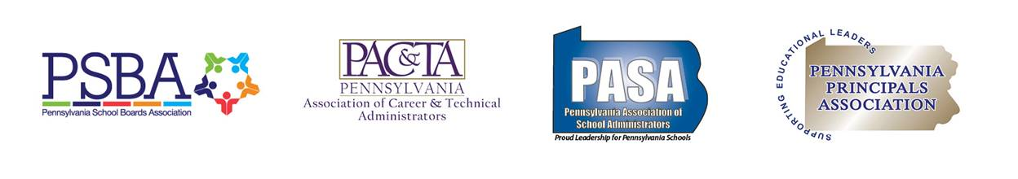March 16, 2019

Pennsylvania House of Representatives

Re: Joint letter of concern regarding HB 297

On behalf of the Pennsylvania School Boards Association (PSBA), Pennsylvania Association of Career and Technical Administrators (PACTA), Pennsylvania Principals Association, and Pennsylvania Association of School Administrators (PASA) and the school leaders that our organizations represent, *we are writing to express our significant concerns regarding HB 297* to be considered on Monday March 18, 2019. While we appreciate the changes to the bill offered by amendment A00278; the amendment unfortunately does not completely address our organizations’ concerns and we maintain our opposition to the bill.

HB 297 would amend the School Code to require public school entities to provide employers with direct access to school services and students and at least one opportunity to speak directly to students.

All of our organizations support the concept of ensuring every public school student is more aware of the educational opportunities available to them through their public career and technology center. However, as currently written, House Bill 297 (P.N. 270) would present substantial difficulties for school leaders in implementing the provisions of the bill. Specifically, our significant concerns include:

* School entities would be required to allow employers to recruit and deliver information to all students enrolled in the school entity and provide equal access to employment/placement services. The language in the bill leaves school leaders unsure as to what this would obligate schools to do.
  + Would this require physical or electronic delivery to all students in every grade? With the term “delivery” undefined, would this provision require schools to actively distribute information to each student or simply make the information available? Would this require schools to allow employers to deliver that information directly to students? How would this provision impact current school internship and cooperative educational opportunities? Does this provision create the potential for liability if a school cannot accommodate every employer and in the manner wanted by the employer?
* Schools would be required to provide employers equal access to their guidance services. The language in the bill leaves school leaders unsure as to what this would obligate schools to do.
  + Would this require schools to allow employers to meet with school guidance counselors? Would guidance counselors be required to pass information regarding employment opportunities along to students? Would these new requirements result in guidance counselors having less time advising students?
* Schools would be required to provide all employers at least one opportunity to speak directly to students in grades 4-12 during the school year to provide age-appropriate information regarding career opportunities.
  + Would schools be required to allow employers who request to speak with students to do so at any time during the school year? Would these opportunities need to take place during the school day? If a school entity has a career fair at a high school, would that qualify as an opportunity and would the entity be required to transport middle and elementary students to the career fair to ensure they have an opportunity to participate? If that career fair were to fill up with employers, would schools be required to hold additional fairs?

Impacts

The bill would open schools to employers in the school community and give employers direct access to students. With no ability for public schools to screen employers to ensure appropriateness and usefulness, public schools could become a hub for employers to fill positions – not just those identified as high-priority or in-demand. Also, with schools concerned about keeping staff and student safe, opening schools up to employers creates another safety issue.

Depending on its interpretation, and due to its broad and vague language, this bill has the potential to result in significant intrusions into instructional time and increased costs for schools. Allowing employers to speak directly to students during the school day would reduce valuable instruction time and force schools to incur transportation costs so all students in grades 4-12 could participate. The new mandate would also add to the workload of school staff who have to respond to inquiries from employers and/or supervise the interaction between students and employers.

Schools are already required to ensure career exploration is taking place as early as elementary school. Under Pennsylvania’s Consolidated plan for implementing the Every Student Succeeds Act (ESSA), students must demonstrate engagement in career exploration and preparation by the end of grade 5 and create an individualized career plan and participate in career preparation activities by the end of grade 8. Such career exploration is required to be aligned with the state’s Career Education and Work academic standards which ensure students understand career options in relationship to individual interests, aptitudes and skills.

Guidance counselors in most schools are already overextended in ensuring their assigned students are doing well academically and socially. If guidance counselors are inundated with access requests from every interested employer, which they would be mandated to work with, it would inhibit their ability to perform their primary job functions.

Granting equal access to school employment and placement services could interfere with current school internship and cooperative educational opportunities. Employers participating in those programs have been vetted and provide appropriate and useful educational work opportunities for students. If schools were required to open those programs up to other employers, schools would lose the ability to ensure that those opportunities provide valuable experiences. Schools may also not be able to accommodate every employer that would like to participate. If schools are required to provide equal access, that could require schools to eliminate internship and cooperative educational opportunities.

Please contact us if you would like to discuss these issues further.

Thank you,

Pennsylvania School Boards Association (PSBA)

Pennsylvania Association of Career and Technical Administrators (PACTA)

Pennsylvania Principals Association

Pennsylvania Association of School Administrators (PASA)