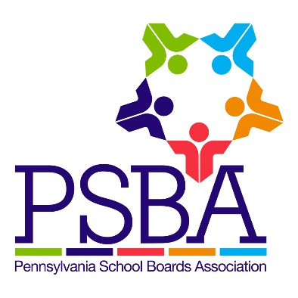

Guidance on the School Safety and Security Board Report
Act 44 of 2018 created School Code section 1309-B (24 P.S. 13-1309-B), which specifies the role and responsibilities for a school entity’s School Safety and Security Coordinator. One of the primary responsibilities of the appointed School Safety and Security Coordinator is to make a report to the school entity’s board of directors by June 30, 2019, and each June 30 thereafter, regarding the school entity’s safety and security. The School Code includes only the following requirements regarding the report:
- The report must address the school entity’s current safety and security practices that identify strategies to improve school safety and security.
- It must be presented at an executive session of the board.
- It must be submitted to the state’s School Safety and Security Committee.
- The report is not subject to the Right-to-Know Law.
The requirements for the report are minimal and allow flexibility for school entities to determine what is most appropriate to be included in their school safety and security board report. The school entity’s governing board, School Safety and Security Coordinator, and other administrators should discuss and determine what information will be most helpful to review and assess an accurate picture of safety and security in the school entity, in order to discuss future needs and resources to make students, staff and school buildings more safe and secure. Below is a list of items that boards may consider including in their school safety and security board report. None of these items are specifically identified by law as required elements of the report, but reflect suggestions PSBA has developed based on the role of the School Safety and Security Coordinator and other legal or regulatory requirements, as well as pertinent data and information already being collected, that would be consistent with the purpose of the report and help to inform the board about the current status and future needs of the entity’s safety and security preparedness:
- Results of required emergency preparedness, fire, bus evacuation and school security drills conducted by the school entity over the past school year. (See Policy 805; 24 P.S. 15-1517, 15-1518; 35 Pa. C.S.A. 7701)
- Information on school safety and security training and resources provided to students and staff—this could include:
  - School safety and security training (required by 24 P.S. 13-1310-B).
  - Suicide awareness and prevention training (required by 24 P.S. 15-1526).
  - Child abuse recognition and reporting training (required by 24 P.S. 12-1205.6).
  - CPR training offered at the school (24 P.S. 12-1205.4).
  - Training with first responders.
  - Safe2Say Something training.
  - List of teams and resources available in the school entity related to school safety and security (i.e., school safety/emergency preparedness teams, Student Assistance, child study or crisis response teams).
- Safe2Say Something aggregate data, including a breakdown of Life Safety and Non-Life Safety reports received, and successes and challenges of program implementation.
Reminder: specific report data should be maintained confidentially to respect anonymity and reflect requirements of the program and state and federal laws regarding student information.
- Behavioral health and school climate information, including aggregate data from surveys and assessments issued in the school entity (such as the PA Youth Survey, School Climate surveys, etc.), information on types of referrals and services accessed by students and families, and identification of additional resources that may be needed in the school entity. Reminder: specific student and family information should be maintained confidentially.
- Office for Safe Schools reports for the previous year(s) and/or data collected to date for the current year. (See 24 P.S. 13-1303-A)
- Updates regarding each of the school entity’s Memorandum of Understanding with local law enforcement agencies. (See Policy 805.1; 24 P.S. 13-1303-A; 22 PA Code 10.11)
- Updates of laws, regulations and/or Board policies related to school safety and security that have been revised in the past year.
- Information on building tours, inspections and/or School Safety and Security Assessments of school facilities and programs, whether they were conducted by internal staff or an outside provider.
- Information on grants or funding applied for and/or received in support of school safety and security efforts (i.e., PCCD School Safety and Security grants, PDE’s Office for Safe Schools grants, PEMA/FEMA grants).

The report may be compiled and formatted in any manner that meets the needs of the school entity in order to present it to the governing board in an executive session. Keep in mind that materials shared regarding the report should remain confidential since they are presented in executive session and are not subject to the Right-to-Know Law. A PowerPoint, Keynote or other type of presentation would work well to present the information to the governing board, and allow a document to be created in order to share it with the state’s School Safety and Security Committee. Other written formats are acceptable as well. A final document reflecting the reported information should be shared as an attachment with the School Safety and Security Committee, using the reporting tool provided to school entities by the Pennsylvania Commission on Crime and Delinquency (PCCD): https://www.surveymonkey.com/r/SSReport2019
PSBA presented a webcast on May 7 detailing the specific requirements of the school safety and security board report and each of these recommendations, as well as further discussion from the school board president and school solicitor perspective on executive session considerations, presenting data to the board, confidentiality requirements and more. A full recording of the webcast is available in myPSBA in the Online Learning section: Annual School Safety and Security Board Reports – What You Need to Know
PSBA’s Policy Services will also be incorporating the requirements and recommendations for the School Safety and Security Board Report in a new policy 805.2 that will be sent out in the upcoming Policy News Network newsletter.
Please contact heather.masshardt@psba.org if you have additional questions regarding PSBA’s recommendations for the board report. If you have questions regarding the reporting tool, please contact PCCD at RA-CD-SSSC@pa.gov.

